Term 4 Newsletter 11 | Thursday 29th March 2018
Plumpton Primary School


Executive Headteacher: Stewart James  Advisory Head: Caitlin Yapp  Head of School: Sally Buchan |  | secretary@plumpton.e-sussex.sch.uk  www.plumpton.e-sussex.sch.uk Address: Southdowns, Plumpton Green, BN7 3EB  Tel: 01273 890338
Dear Parents and Carers,  A very warm spring welcome to the final newsletter for this term! We have had such an exciting and busy time at school, so I hope you enjoy reading all about it!  Sport Relief    Last week, the whole school took part in Sport Relief with the aim of running 4000 miles – the total distance between here and Kenya. Thanks to the AMAZING effort from all the children, staff, family and friends we are very proud to announce that we ran a total of 4,030 miles! The children have also been bringing in their sponsor money and so far we have raised an impressive £850! Well done and thank you to everyone!  World Book Day  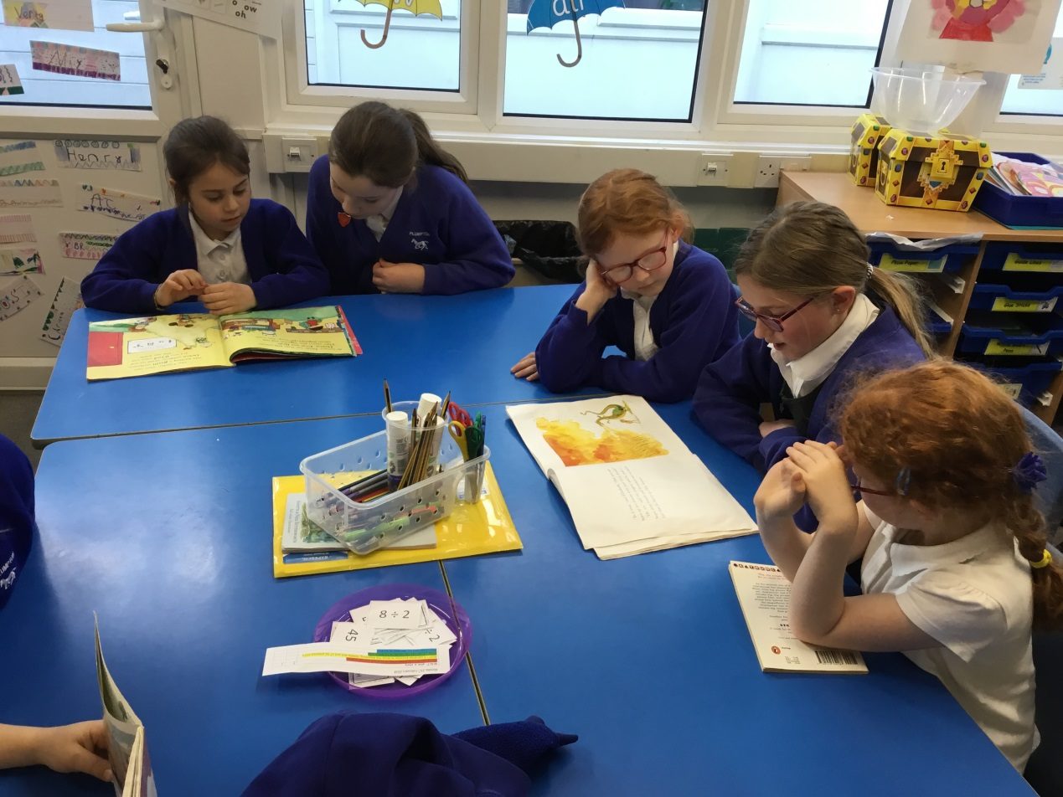  On Thursday 8th March, we celebrated World Book Day. The children fully immersed themselves by dressing up as a character from their favourite book. We also welcomed parents and grandparents to the school to read to the children, which ensured the day was a wonderful success. If you haven’t done so already, please look at the class blogs for all the photos.  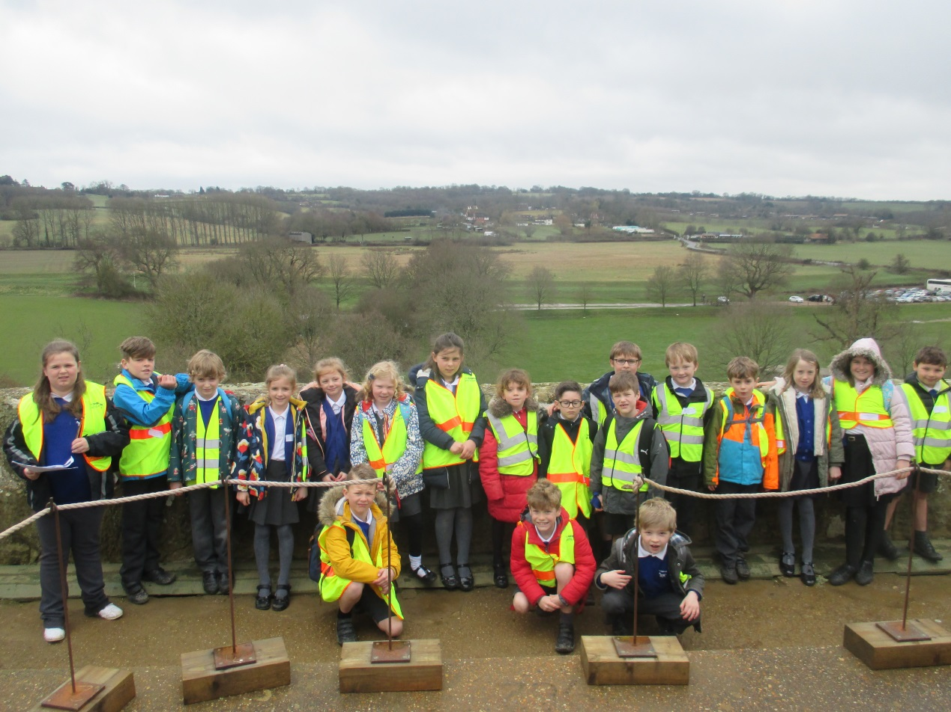  Bodiam Castle  On Tuesday 27th March, KS2 visited Bodiam Castle. The day included a tour of the castle, an historical quiz, story-telling, medieval role play and learning what it was like to live and work inside the castle. The trip was a superb and fitting ending to this term’s topic and the children had a wonderful day – despite the damp start!  Wonderful Work Assembly  Every term, Mr James leads our Wonderful Work assembly. Each teacher selects two children from their class who they believe have made an exceptional effort with a particular piece of work. The children’s work is then put on display. Congratulations go to Daisy Ainger and Koya Baker (Robins), Roscoe McIlwain and Eloise Croucher (Woodpeckers), Rosie Holden and Stanley Springham (Kingfishers), Rosa Linney and Lauren Dejonge (Owls). Well done to you all!  Book Fair – Reminder!  Don’t forget the Scholastic book fair arrives on Thursday 26th April and will be here until Thursday 3rd May. Books will be available to purchase at the end of each day.  Attendance  Attendance continues to be an important focus in school. If your child is unable to attend school (due  to illness) please contact the school office daily by 9.00am on 01273 890338. Here are the attendance results up to 29th March 2018:  Congratulations to Owl Class.  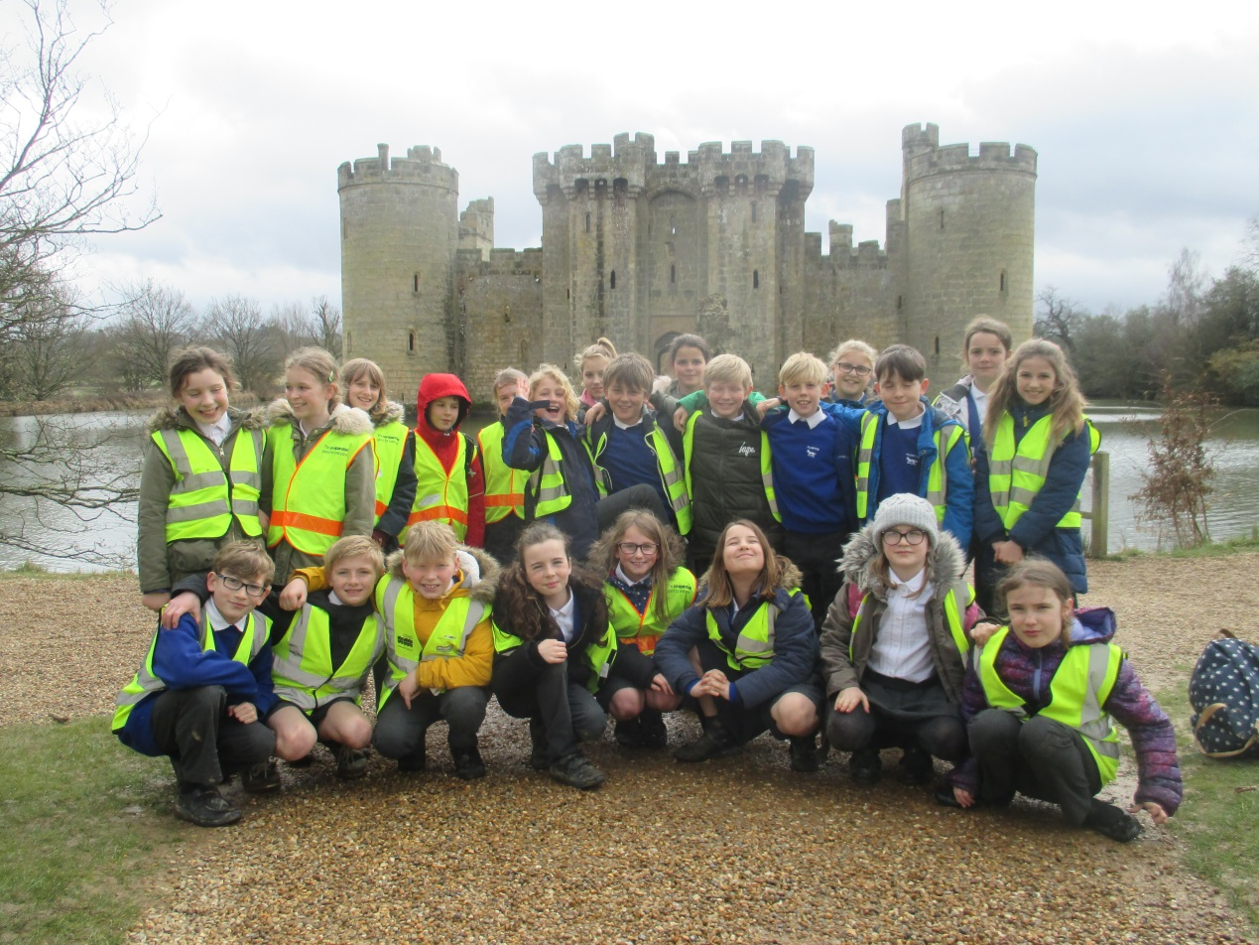 |  | Paradise Park  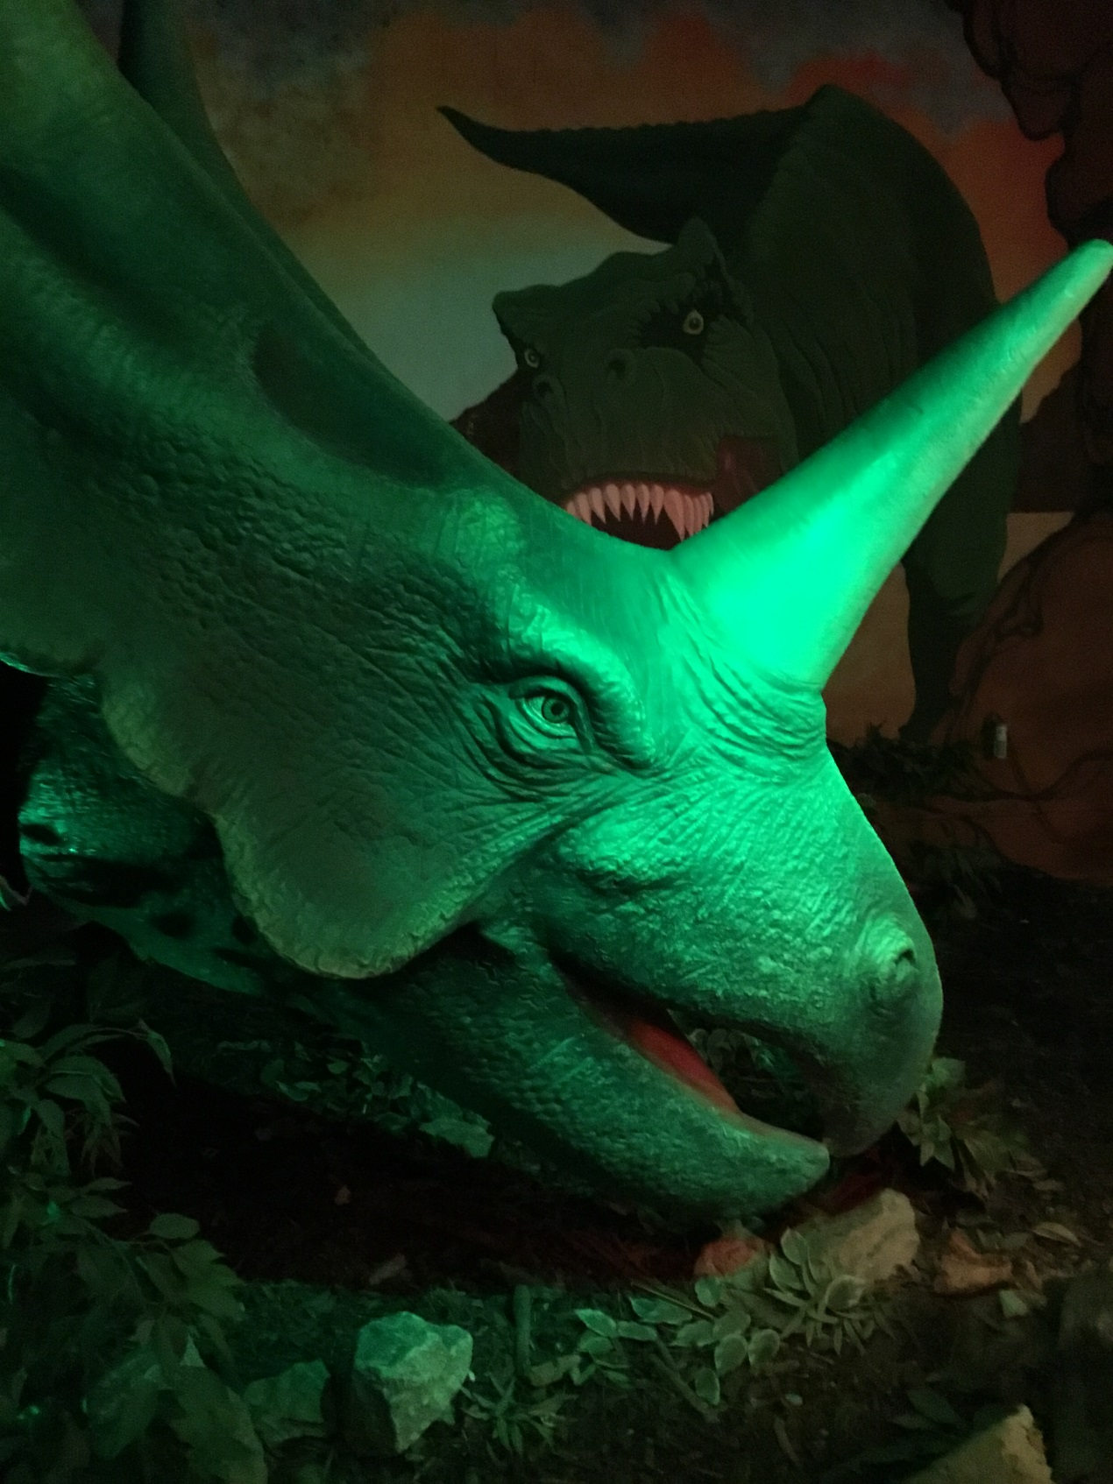  On Tuesday 13th March, the whole of KS1 visited Paradise Park in Newhaven as part of their topic on Dinosaurs. We had a fantastic day and, not only did the children behave brilliantly, but they all thoroughly enjoyed themselves! We did have to be very brave because some of the dinosaurs were very big and very loud!  Whole School Music Day  On Friday 16th March, Mrs Jane Humberstone from the East Sussex music service spent the day teaching topic themed music workshops throughout the school. KS1 composed their own ‘Dinosaur’ pieces using a variety of unpitched instruments, while KS2 wrote their own compositions linked to ‘Castles’ and used both pitched and unpitched instruments. We all came together to celebrate in a final assembly, during which the children performed their work. A huge THANK-YOU to the PTA for funding this event!  Class Assembly  We hope you enjoyed watching your child’s class assembly this term. The children work very hard and are extremely proud to celebrate their achievements with family and friends. The next class assemblies will be in Term 6 – dates to follow.  Class Blogs  Don’t forget to look at your child’s class blog for up to date information. Class blog addresses:  Robin Class:  plumptonrobins.wordpress.com  Woodpecker Class: plumptonwoodpeckers.wordpress.com  Kingfisher Class:  plumptonkingfishers.wordpress.com  Owl Class:  plumptonowls.wordpress.com  Dates for your diary    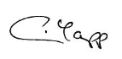  Best wishes,  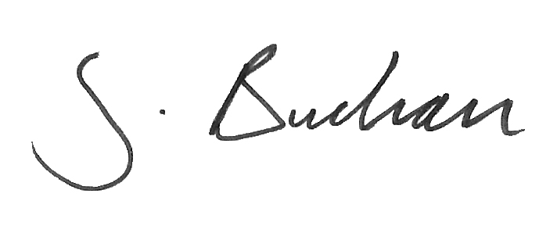  Sally Buchan Caitlin Yapp Stewart James  Head of School Advisory Head Executive Head
  Class | Attendance
  Robins | 90.1%
  Woodpeckers | 95.7%
  Kingfishers | 95.9%
  Owls | 96.1%
  March 2018
  Friday 30th March – Friday 13th April | EASTER  HOLIDAY
  April 2018
  Monday 16th |  | First day of Term 5
  Monday 23rd – Friday 27th April (not Wed.) |  | Parent Curriculum Meetings
  Thursday 26th until  Thursday 3rd May |  | Scholastic Book Fair
  May 2018
  Wednesday 2nd |  | Y5 science at Cumnor House
  Monday 7th |  | BANK HOLIDAY – SCHOOL CLOSED
  Monday 14th - Thursday 17th |  | Year 6 SATs week
  Monday 14th –  Friday 18th |  | Year 5 Bikeability  1pm – 2.30pm
  Friday 25th |  | Year 6 Safety in Action
  Friday 25th |  | Last day of Term 5
  Monday 28th –  Friday 1st June |  | HALF TERM
  June 2018
  Monday 4th |  | First day of Term 6
  Wednesday 6th |  | Y5 science at Cumnor House
  Wednesday 6th |  | Parent Forum 6pm – 7pm
  w/c Monday 11th |  | Year 1 National Phonics Screening
  Wednesday 13th |  | Year 5 to Hindleap Warren
  Wednesday 20th – Friday 22nd |  | Year 6 Residential  to PGL, Windmill Hill
  Wednesday 27th |  | Sports Day
  July 2018
  Friday 6th |  | Year 6 PATINA parade
  Monday 9th –  Friday 13th |  | Year 6 Bikeability  1pm – 3pm (not Thursday)
  Thursday 12th |  | Year 5/6 Connect to the Countryside at Ardingly
  Thursday 19th |  | Year 6 Leavers Assembly 2.30pm
  Thursday 19th |  | Last day of Term 6
  Friday 20th |  | INSET DAY

